Topic 1a Cell Structure and Cell Division

1. Cell Structure

All living things are made of cells — they’re the building blocks of every

organism on the planet. But different organisms have different cell structures...

Prokaryotes and eukaryotes

Cells can be either prokaryotic or eukaryotic. Eukaryotic cells are complex and include all animal and plant cells. Prokaryotic cells are smaller and simpler, e.g. bacteria (see next page).

Eukaryotes are organisms that are made up of eukaryotic cells. A prokaryote is a prokaryotic cell (it’s a single-celled organism).

Both eukaryotic and prokaryotic cells contain various cell parts called subcellular structures.

Animal cells

Most animal cells have the following subcellular structures — make sure you know them all. The parts are labelled in Figure 1.

Nucleus — contains genetic material that controls the activities of the cell.

Cytoplasm — a gel-like substance where most of the chemical reactions happen. It contains enzymes (see p. 115) that control these chemical reactions.

Cell membrane — holds the cell together and controls what goes in and out.

Mitochondria — these are where most of the reactions for aerobic respiration take place (see p. 173). Respiration transfers energy that the cell needs to work.

Ribosomes — these are where proteins are made in the cell.

cytoplasm
nucleus
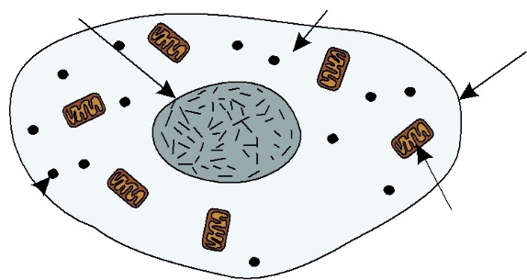
cell membrane

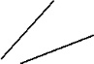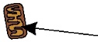 mitochondria ribosomes

Learning Objectives:
Know that plant and animal cells are eukaryotic cells, and that bacterial cells are prokaryotic cells.

Understand that prokaryotic cells are much smaller than eukaryotic cells.

Know that most animal cells have a nucleus, cytoplasm, cell membrane, mitochondria and ribosomes, and know the function of each of these parts.

Know that plant and algal cells have the same parts as animal cells, plus a cell wall.

Know that plant cells also usually have a permanent vacuole and chloroplasts, and know the function of each of these parts.

Know that bacterial cells have a cell wall, cell membrane, cytoplasm, a single loop of DNA and may have plasmids, and know the function of each of these parts.

Specification References

4.1.1.1, 4.1.1.2
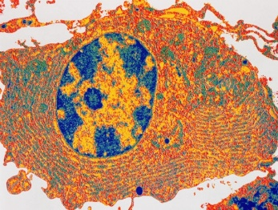

Figure 2: A human cell seen Figure 1: The structure of a typical animal cell. under a microscope — the blue and yellow oval is the

nucleus.

Topic 1a Cell Structure and Cell Division 23

Tip: The diagrams on this page and the previous one all show ‘typical’ cells.

In reality the structure of a cell varies according to what job it does, so most cells won’t look exactly like these.

mitochondria cell wall
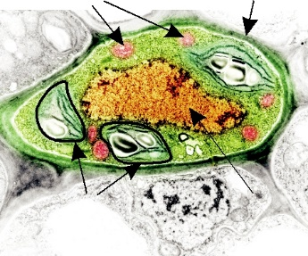

chloroplasts nucleus

Figure 3: A cross-section of a plant cell seen under a microscope.

Tip: Bacterial cells contain ribosomes, but they don’t contain any chloroplasts or mitochondria.
Plant cells

Plant cells usually have all the bits that animal cells have, plus a few extra:

Cell wall — a rigid structure made of cellulose. It supports and strengthens the cell. The cells of algae (e.g. seaweed) also have a rigid cell wall.

Permanent vacuole — contains cell sap, a weak solution of sugar and salts.

Chloroplasts — these are where photosynthesis occurs, which makes food for the plant (see page 158). They contain a green substance called chlorophyll, which absorbs the light needed for photosynthesis.

The subcellular structures of a typical plant cell are shown in Figure 4.

 | permanent | cell
 | vacuole
nucleus |  | membrane
 |  | ribosomes
cell wall |  | chloroplasts
mitochondria |  | cytoplasm
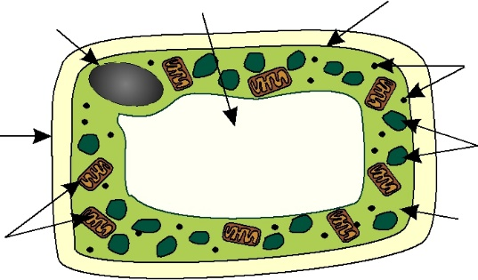
Figure 4: The structure of a typical plant cell.

Bacterial cells

Bacteria are prokaryotes. A bacterial cell has cytoplasm and a cell membrane surrounded by a cell wall. The cell doesn’t have a ‘true’ nucleus — instead

it has a single circular strand of DNA that floats freely in the cytoplasm (see Figure 5). Bacterial cells may also contain one or more small rings of DNA called plasmids.

cell membrane | cell wall
cytoplasm | circular strand
 | of DNA
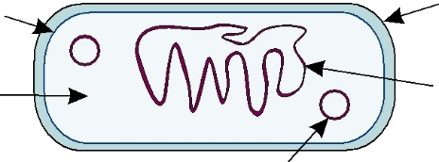
plasmid

Figure 5: The structure of a typical bacterial cell.

Exam Tip
You need to learn the functions of the subcellular structures, not just their names.

Practice Questions — Fact Recall

Q1 Which part of an animal cell controls its activity?

Q2 Where do most of the chemical reactions take place in a cell? Q3 What are mitochondria needed for in a cell?

Q4 Name three things that a plant cell usually has, that an animal cell doesn’t.

Q5 What is a plasmid?

24 Topic 1a Cell Structure and Cell Division

